**Once A Child Laborer, Now An IITian**

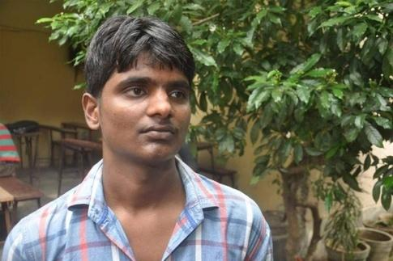

* **Very humble and harsh beginning.**

Sujeet was born in Pureni village of Madhepura District in Bihar. It is at the bank of river Kosi, the infamous river called ‘Bane of Bihar’. There was no employment and people were depended on farming, that too at the mercy of violent river of Kosi. If it rained the crops were good but flood ruined it. His father used to live on farming if it is not ruined by river or drought. He did not have his own land neither he was educated for the job. The family of four kids was dependent of farming or else his father had to do hard labor nearby towns.

* **Mother’s advice and naive Sujeet:**

With time kids grew and Sujeet was now old enough to go to school. His father busy in daily hard work didn’t have time to think about kids’ study. But his mother Meera Devi wanted to make their kids educated. She was uneducated but always encouraged kids about study. Mother’s words clicked young Sujeet and he started going to school in the village. By the time he reached class 4th the condition of the school went bad to worse, there was no one to answer his queries, and he was scolded on asking questions. This made him lose interest in studies. Moreover he saw kids of his age working and earning money for family, it added to his deviation from study.

* **Meeting harsh truth called life:**

Sujeet thought of leaving the school and go to the work as other kids were doing but his mother stopped him from doing it. During that time his grandfather got ill and due to lack of money they couldn’t treat him. His father tried to collect money from borrowing but could not mange and his grandfather died. Now Sujeet was broken and he decided to drop out of the school

* **An elderly advice:**

Hearing this; an elderly man in village asked him not to do so and offered help if he needed. His mother also pushed him for study. And once again he started studying.

* **A dream and failure:**

He thought of going to Navodaya School as the fee was less and study was good there. But he failed in entrance. Well to do kids from his village mocked him on his failure and dream. But he did not give up and kept studying in the same school. He reached to class tenth but that year Kosi river flooded and ruined entire village.

* **The dilemma and a choice:**

Kids from poor families came to him and asked to join them at work out of village in cities and other states. But his mother did not let him go. And by now he also understood that working is not the solution, only education can get them out of abject poverty.

* **The challenge and the fight:**

His house was a temporary arrangement made up of weed, thatch, leaves, wood so it leaked in rainy season making it hard to stay in. This did not deter him and he kept on studying hard day and night. He didn’t even have enough money to fill the form for the 10th board exam. So he started tutoring kids in and around the village. And by the time of filling form, he had enough cash with him and few extra bucks.

* **First taste of winning and a dream:**

In Patna he went door to door tutoring kids and collected money for books and stationary and started preparing for entrance. During those days he heard of Super 30, and went to meet Anand Kumar . Hearing his heart-wrenching story and dedication he asked him to join in. And here he toiled for day and night. He would hardly sleep in the night. If Anand asked, he would say “my father would be doing hard labor this time so should I”. He earned goodwill among other students too. As he used to help them in studies.

* **And the dream came true:**

Finally he gave IIT entrance test with confidence and was sure of cracking it. And his hard work paid off, he got selected for IIT BHU in June last year.  
His mother doesn’t know what IIT is. But she thinks now the days of destitution are fading away and one day it will be all over. His father still works that hard, as he knows that he can’t be dependent on Kosi River for farming. And he believes river Kosi cannot wash away their survival and dreams with its wicked tides anymore.